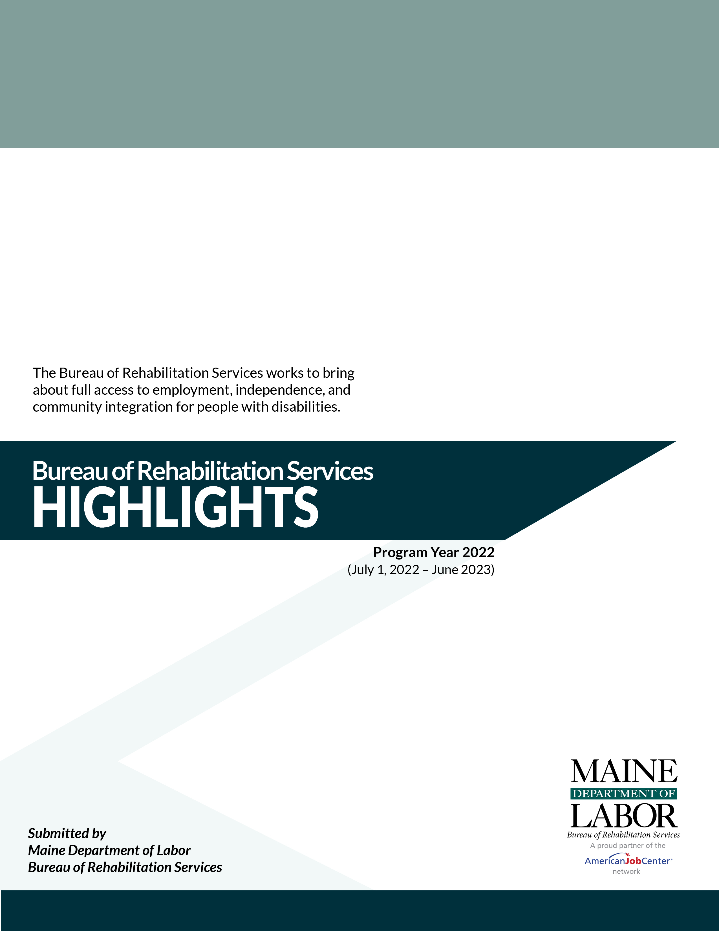

This Page Intentionally Blank

STATE OF MAINE
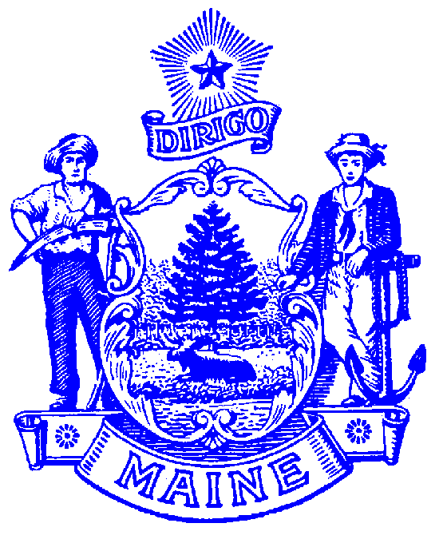
DEPARTMENT OF LABOR
BUREAU OF REHABILITATION SERVICES
150 STATE HOUSE STATION
AUGUSTA, MAINE 04333-0054

LAURA A. FORTMAN
COMMISSIONER

JANET T. MILLS
GOVERNOR

Bureau Director’s Message

“If we are to achieve a richer culture, we must weave one in which each diverse human gift will find a fitting place.” – Margaret Meade
Welcome to the 2023 edition of our BRS Highlights! I can think of no better quote that captures the essence and purpose of the Bureau of Rehabilitation Services (BRS). As part of the Maine Department of Labor, we are proud to be helping Maine thrive through the contributions of people with disabilities throughout our beautiful state, ensuring that we all prosper in a diverse and inclusive place to live and work.

This year marks the 50th anniversary of the Rehabilitation Act, which was the first civil rights legislation that protected people with disabilities from discrimination and paved the way for the Americans with Disabilities Act and other disability rights advancement that continue to this day. For BRS, the charge remains vitally important and is clearly expressed in its preamble: “To Empower Individuals with Disabilities to Maximize Employment, Economic Self Sufficiency, Independence, and Inclusion and Integration into Society.”

On a state and national level, people with disabilities are engaged in their communities and participating in workforce at historical highs. Employers are benefiting from the skills and talents of this diverse group of workers. Yet, we know that people with disabilities are still greatly underrepresented and BRS remains committed to continuing the trajectory for full disability employment. This includes investing in our youth who are preparing for careers and helping older adults who want to stay in the workforce, as well as the many others who have been on the sidelines of our communities for years.

Throughout this publication, we highlight some of our many initiatives and most importantly the successes of those who come to us. There has been much accomplished and much more to be done.
Karen Fraser, Bureau Director

PHONE: (207) 623-7943 TTY users call Maine Relay 711 FAX: (207) 287-5292
The Maine Department of Labor provides equal opportunity in programs, services and employment.
Auxiliary aids and services are available to individuals with disabilities upon request.
Programs are provided as a proud partner of the American Job Center network.

Table of Contents

Bureau of Rehabilitation Services Overview 1
How We Define Success… 2
Division of Vocational Rehabilitation (DVR) 3
DVR Initiatives and Innovations 4
Bureau of Rehabilitation Services (BRS) Apprenticeship Program 5
Division for the Blind and Visually Impaired (DBVI) 6
DBVI Initiatives and Innovations 7
Division for the Deaf, Hard of Hearing and Late Deafened (DDHHLD) 8
Office of the State Accessibility and Independent Living Coordinator 9
Partners in Advocacy, Advisory Boards and Councils 10
BRS Office Directory 11

Bureau of Rehabilitation Services Overview
The Bureau of Rehabilitation Services (BRS) is comprised of three Divisions – the Division of Vocational Rehabilitation (DVR), the Division for the Blind and Visually Impaired (DBVI), and the Division of Systems Improvement and Quality Assurance (SIQA). As Maine’s tight labor market continues, BRS has had an average of 128 employees delivering public vocational rehabilitation and independent living services to people with disabilities throughout the last year. Co-located at CareerCenters statewide, BRS also houses the Office of the State Accessibility Coordinator, who leads the State’s compliance under the Americans with Disabilities Act (ADA) and Section 504 (see page 9).

The Rehabilitation Act of 1973, as amended by the Workforce Innovation and Opportunity Act (WIOA) of 2014, establishes program eligibility and the scope of services provided through DVR and DBVI. Included are vocational counseling and guidance, physical restoration services, education and skills training, and job placement services. DBVI, in conjunction with the Department of Education, also serves all children who are blind in Maine.

This past year, 8,092 Mainers with disabilities received services from BRS; of those participants, 6,212 received services with a plan for employment. Counselors worked with clients who had an employment plan, on average, for 775 days or about 25 months. A total of 561 clients were successfully employed earning an average wage of $536.97 per week.

BRS receives most of its funding from federal grants, some of which require matching state funds. The largest (one administered by DVR and one administered by DBVI) are from the Department of Education’s Title I grant program for vocational rehabilitation services.
Federal Grants Required General Fund Match
Vocational Rehabilitation 4:1 (21%)
Independent Living 9:1 (11%)
Supported Employment - Youth 10%
Supported Employment - Adult None

Special Revenue income is received from the Business Enterprise Program, the Worker’s Compensation Board, and the Public Utilities Commission for telecommunications. The use of the Special Revenue funds is restricted for these specific purposes.

How We Define Success…
“Colton” a young person with an Autism diagnosis participated in the PEERS program, gaining social skills and confidence. He showed off those new skills speaking about his work-based learning opportunity before a large group of employers!
“Dennis” was able to maintain employment as the department head of a large grocery store thanks to assistance with hearing aids from his Rehabilitation Counselor for the Deaf. Dennis shared that access to services made a “huge difference in both my professional and personal life.”
“Samara” a woman with a visual impairment, was determined not to let anything stop her from reaching her goals. With DBVI’s assistance, she attended college and completed a bachelor’s degree in psychology. Within three months of graduation, she was employed full-time at a behavioral health treatment center.
Having left high school with not clear next steps, “Jared” and his VR Counselor explored opportunities available through his town’s Career & Technical Education (CTE) Center. After touring the Center, Jared got excited about the career pathways available in Robotics through CTE and enrolled!
“Andrea” was looking for new opportunities when she applied for VR services. In partnership with the local CareerCenter, she was able to get the support needed to gain her CDL license. Following licensure, she applied and was hired by a local town in their Public Works department earning a competitive wage with full benefits – and becoming their first female hire!
“Janie,” a young woman with mental health disabilities, has successfully become employed in a customer service role for a large retailer. VR assistance via regular check-ins and limited job coaching – along with strong family support – allowed Janie to grow in her job and demonstrate her skills. Janie shared that she likes the feeling of independence and maturity that her employment offers her.
Marco,” a young man with a visual impairment, used an on-the-job learning opportunity to build
skills in repairing and installing pellet stoves. Marco’s employer has been welcoming and has met his accommodation needs. They are already looking to promote opportunities in a new store they are opening!

Division of Vocational Rehabilitation (DVR)
Libby Stone-Sterling, PhD, Director
Maine’s DVR assists individuals with disabilities who wish to achieve, retain, or advance in employment. Any person who wants to pursue employment and has a disability that creates a barrier to employment is encouraged to apply. Once determined eligible, individuals develop a plan for employment, which outlines the services needed to successfully achieve their employment goal.

Contributing to the Maine Economy
While maintaining a wait list for services, DVR assisted 532 people to find employment success over the last year. This resulted in these individuals earning a total of $14,641,602.04 in annual wages. Across the state and across industry sectors, DVR clients are joining or rejoining the workforce in jobs such as:

Accountants and Auditors | Dishwashers | Janitors and Cleaners
Administrative Services Managers | Drywall and Ceiling Tile Installers | Machinists
Advertising Sales Agents | Electricians | Medical Assistants
Aircraft Mechanics and Service Technicians | Engineering Technicians | Nursing Assistants
Bakers | First-Line Supervisors Retail Workers | Office Clerks
Building Cleaning Workers | Food Service Managers | Packers and Packagers
Carpenters | General and Operations Managers | Personal Care Aides
Cashiers | Grounds Maintenance Workers | Postal Service Clerks
Childcare Workers | Healthcare Support Workers | Registered Nurses
Cleaners of Vehicles and Equipment | Heavy and Tractor-Trailer Truck Drivers | Retail Salespersons
Community and Social Service Specialists | Helpers – Production Workers | Sales Representatives
Community Health Workers | Human Resource Specialists | Social Workers
Customer Service Representatives | Information and Record Clerks | Teachers
Data Entry Professionals | Insurance Claims & Policy Processing | Welders

Individuals Served
3,097 New VR Applicants
2,639 Youth with Disabilities who received Transition Services
5,957 Received Services through Employment Plans
532 Individuals Successfully Employed

DVR Initiatives and Innovations
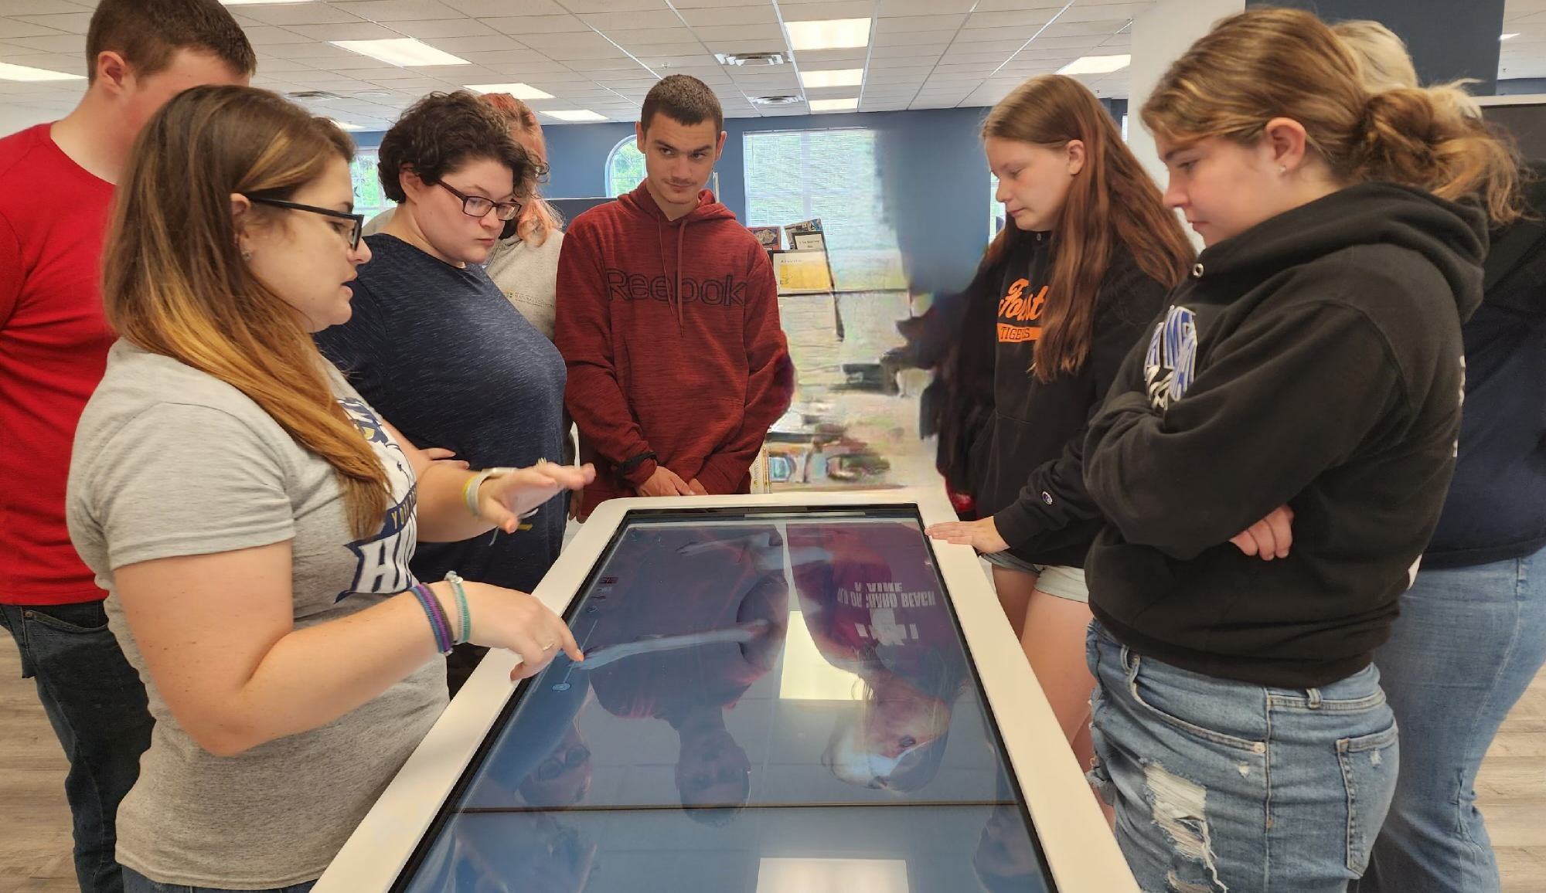
Windmills – Disability Awareness Training – The DVR Business Team has added Windmills to their employer engagement toolkit this year. Available upon request, and able to be customized to meet the business or organization needs, Windmills is a highly interactive disability inclusion training that empowers and equips employment professionals to understand the business community and help businesses to become more inclusive of individuals. Following Windmills’ training, participants have reflected that they are much more aware of the impact of their beliefs about what people with disabilities can contribute. Windmills promotes equity and inclusion of people with disabilities both at work and in the community.
1Above: Students visiting community colleges and universities during a College Bus Tour in 2023.

College Bus Tours – Many Maine students with disabilities do not have the opportunity to visit colleges first-hand as they consider their post-secondary plans. To address that need, last year DVR launched a Pre-Employment Transition Services program – taking high school students on two one-week bus tours of community colleges and universities across Maine. Students met with college staff, toured campuses, slept in the residence halls and ate cafeteria food all while making friends and increasing their knowledge of Maine’s numerous higher education opportunities! Some students even learned about college acceptance decisions while they were on the bus tour! Year Two of the initiative saw participation numbers significantly increase as more youth, schools, and families learned about the program.

Step Up – Summer College Prep Experience – Students with Autism Spectrum Disorders (ASD) may find the social and sensory college environment a challenge. Step Up was developed to support high school students who are interested in pursuing post-secondary education by providing the opportunity to experience college residence hall and academic life during a summer residential program at the University of Maine. Celebrating its 5th year in 2023, Step Up includes career exploration and social skills building activities.

PEERS® - Program for the Education and Enrichment of Relational Skills (PEERS®) is world-renowned for providing evidence-based social skills treatment. Through a research partnership with Dr. Sarah Howorth at the University of Maine, certified DVR staff began offering PEERS via telehealth during the COVID-19 pandemic and have continued to run ongoing groups to youth and young adults ages 14 to 24 with Autism Spectrum Disorders (ASD) around the state.

Virtual Services Reach Individuals in Rural Areas – DVR’s virtual services continue to increase due to their quality and ease of access. From Pathful Explore (formerly Virtual Job Shadow) to Career Exploration Workshops to Virtual Job Clubs to employer interviews – DVR is finding success in reaching individuals of all ages in rural areas! DVR is also continuing a computer and hotspot loan initiative that has proven useful in increasing access to programs and services.

Progressive Employment – Since launching a pilot in 2015, DVR has continued to expand opportunities for youth and adults through the Progressive Employment dual customer approach that uses a unique teaming strategy called “Jobsville” and a series of coordinated work-based learning activities to promote career exploration for jobseekers while introducing employers to a new talent pool. The model continues to open doors for individuals who experience multiple barriers to employment.

Targeted Population Liaisons – Each office has established a liaison with subject area knowledge related to Foster Care, Corrections, Veterans, and individuals with I/DD to best support coordination and improved outcomes for mutual clients. These liaisons serve as a point of contact and assist with promoting connections within and outside Vocational Rehabilitation.

Partnership to Increase Competitive Integrated Employment Outcomes – DVR has long had a strong partnership with DHHS – Office of Aging and Disability Services, but with the implementation of the Home and Community Based Settings (HCBS) Rule, collaboration has increased. One example of this collaboration was participation in a six-month series of joint training designed to promote improved service delivery and employment outcomes for people with Intellectual and Developmental Disabilities (I/DD).

Bureau of Rehabilitation Services (BRS) Apprenticeship Program
The year 2023 represents a period of strong growth and expansion of apprenticeship within the Bureau of Rehabilitation Services. Building on the apprenticeship foundational efforts laid the previous year, which included hiring of a full time BRS Apprenticeship Navigator, awarding of $12 million in grant funds to help expand pre-apprenticeship and apprenticeship to statewide apprenticeship sponsors throughout Maine and implementing DEIA efforts including implementation of “Windmills Disability Awareness” training, BRS was able to engage our vocational rehabilitation clients in unprecedented numbers and continues to be viewed by other state VR offices as a mentor state in apprenticeship engagement. This year the Maine Bureau of Rehabilitation Services (BRS), in continued partnership with the Bureau of Employment Services (BES), and the Maine Apprenticeship Program (MAP), apprenticeship accomplishments include:
- Participating as panelists in Jobs for the Future and Institute for Community Inclusion’s Innovation Hub Spring Virtual Summit to discuss Maine’s inclusion practices for Registered Apprenticeship.
- Providing Windmills disability awareness training to all 14 Maine Jobs and Recovery Plan grant recipients in order to promote inclusive hiring practices in apprenticeship.
- Participating in American Institutes for Research (AIR) Systemic Strategies for Increasing Diversity, Equity, Inclusion, and Access (DEIA) in Apprenticeship innovation cohort with other selected states to develop solutions to specific apprenticeship expansion challenges.
- Working with VRTAC-QE Apprenticeship Learning Community as part of a cohort of 8 state apprenticeship agencies and partners to develop a National Apprenticeship Toolkit for use by state vocational rehabilitation (VR) agencies to include employer support and VR agency business services integration, strategies for collaborating with State Offices of Apprenticeship, apprenticeship grant funding opportunities, resources and information to equip VR counselors with the tools to prepare VR customers for pre-apprenticeships and registered apprenticeships.
- Working with Maine Public Schools to support youth with disabilities entering pre-apprenticeship: Presenting to Maine Special Education Directors, Adult Education facilities, Career & Technical Education schools, high schools and colleges, including York County Community College Career Summit.
Mentoring
Participating Registered Apprenticeship Sponsors provide on-site mentors as a requirement of apprenticeship.

Flexibility
Apprenticeships vary in duration (generally 1 to 4 years), are offered by both small and large businesses, and are tailored to meet the needs of the employer.

Earn While You Learn
Apprentices are paid employees from the first day of the apprenticeship.

National Occupation Credential
Upon completion of an apprenticeship, the apprentice is awarded a nationally recognized, portable credential.
- Working with the Division for the Deaf, Hard of Hearing, and Late Deafened to develop an American Sign Language Interpreter Registered Apprenticeship Program with partner agencies and employers.
- Recent placement to include: 3 DVR clients in apprenticeship, 10 DVR clients in pre-apprenticeship, and 1 DBVI client in pre-apprenticeship.
- Sharing BRS’s Apprenticeship practices at the Council of State Administrators of Vocational Rehabilitation (CSVAR) with Burton Blatt Institute at Syracuse University.
- Developing trainings for National Apprenticeship Week targeted for use of BRS services to support apprentices and pre-apprentices with disabilities including an employer targeted lunch and learn “BRS and Your Talent Pool.”
- Continuing to meet quarterly with Maine workforce partners, including the Veterans Administration, Eastern Maine Development Corporation, Coastal Counties Workforce, Inc., the Urban Institute, and the Maine Department of Health and Human Services.

For more information, contact Amanda Muller at: Amanda.Muller@maine.gov or at 207-217-0158.

Division for the Blind and Visually Impaired (DBVI)
Brenda Drummond, Director
Maine’s DBVI provides a continuum of rehabilitation services to individuals who are blind or have low vision. Services may include individual counseling and guidance related to employment and adjustment to blindness issues, use of adaptive technology, low vision therapy, alternative skill training in communication (such as braille), instruction to develop independent travel skills (orientation and mobility), and instruction of daily living skills geared to being more self-sufficient. These services are provided through various programs:

Vocational Rehabilitation Program (VR) is primarily for working-age youth and adults who seek competitive, integrated employment. Services may include individual vocational counseling and guidance, vocational assessment, orientation and mobility instruction, low vision services, independent living services (vision rehabilitation therapy), and more.

Business Enterprise Program (BEP) provides training and support to four licensed managers who operate snack bars, cafeterias, micro markets, and vending machines at 24 sites on state, federal, and municipal properties across Maine. BEP also provides employment to many other individuals with disabilities.

Independent Living Services (IL) provides training in adaptive skills and alternative techniques for accomplishing daily tasks that enable adults who are blind or visually impaired to be more self-sufficient. This year, 282 individuals applied for IL services and 477 received services through an individualized plan. Of the total 512 individuals served, eighty-four percent were over age 65.

Education Services for Children Who Are Blind or Visually Impaired provides adaptive instruction services or consultation to approximately 300 students annually in home or at local schools related to academics and independence.

Individuals Served
85 New VR Applicants
74 Youth with Disabilities Received Transition Services
255 Received VR Services through Employment Plans
29 VR Individuals Successfully Employed

DBVI Initiatives and Innovations
Business Enterprise Program (BEP) In 2023, BEP successfully served Maine’s 131st Legislature while in session, provided concession services at one of Maine’s busiest State Parks, trained a new BEP Manager who is operating a Micro Market and worked with the University of Maine Systems and its vendors to provide food and beverage vending services Statewide for a 5-year term. BEP strives to build strong partnerships with State, Federal and public agencies, as well as the private sector. BEP has adapted to changes in workforce (space and taste) and will continue to find ways to serve employees and customers well.

Winter Outdoor Leadership & Fun (WOLF) Camp was a weekend program provided for the first time by the Division for the Blind & Visually Impaired, in conjunction with the University of Maine’s Maine Bound. This program ran from February 18th – 19th on the UMaine Orono campus. DBVI students participated both days in team building, problem-solving, self-advocacy, and leadership skill development activities that included designing a program for younger DBVI students to complete on Sunday. There was an opportunity for peer connections and mentoring throughout the weekend, and the students challenged themselves and each other while having fun!

Learning, Independence, Fun and Employment (LIFE) Camp was a two-week residential program focused on pre-employment transition services (Pre-ETS) for students with visual impairments. Students worked on adaptive home and personal management skills, including cleaning, budgeting, food prep, organization, and orientation & mobility. They identified their strengths and interests and how those related to employment. Students participated in hands on career exploration to include appropriate social skills, and basic interview strategies. They also participated in assistive technology classes, identifying individual accessibility options to meet their needs, and practiced basic computer skills. Self-advocacy skills were an integral part of the program, emphasizing choice and expressing needs. LIFE Camp introduced students to independence, employment, and empowerment!

No Barriers was a weekend, residential camp for students to participate in team building activities including rock wall climbing, zip lining, and hiking, while immersing themselves in the “7 life elements” of the No Barriers Curriculum developed by Erik Wiehenmayer, the first blind individual to climb to the summit of Mt. Everest. For the third year, the students stayed at the UMaine 4-H Camp and Learning Center at Bryant Pond in Woodstock, ME. The training is designed to empower students to overcome their own personal barriers and, eventually, share with others.

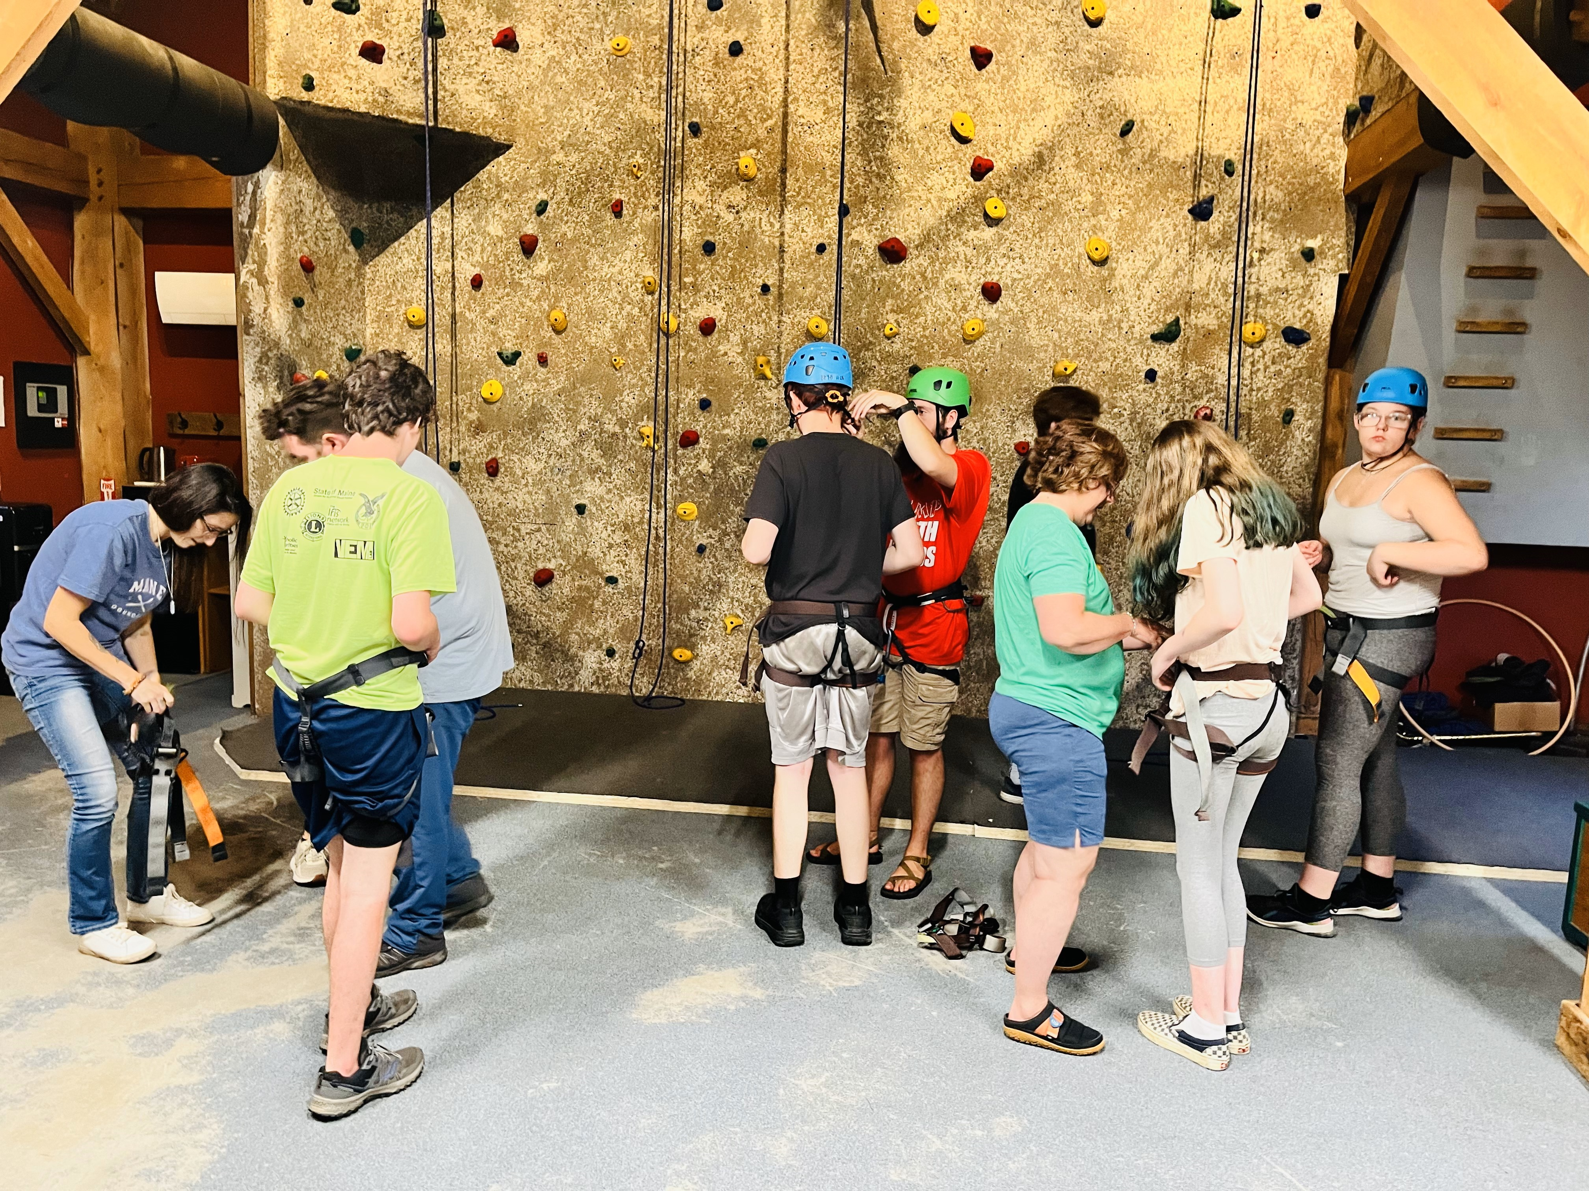
The participants from No Barriers along with their belayers/guides preparing to ascend the climbing wall.

Recruitment for Orientation & Mobility Instructors is underway! DBVI has also been working on some recruiting/outreach efforts for some of our specialized positions, such as Orientation and Mobility Instructors. This video is done by current Orientation & Mobility Instructors to demonstrate what a great place Maine is to work: https://f.io/f4UER5Zj

Division for the Deaf, Hard of Hearing and Late Deafened (DDHHLD)
The Division for the Deaf, Hard of Hearing and Late Deafened (DDHHLD) provides information and referrals for resources of interest to people who have hearing loss throughout the state. This includes such things as interpreting services, hearing aids, and advocacy. The Commission for the Deaf, Hard of Hearing and Late Deafened (CDHHLD) created and actively works on an ongoing Five-Year Plan, which can be found at https://www.maine.gov/rehab/dod/index.shtml.

Other accomplishments of the Division included providing Deaf Awareness trainings to a wide range of audiences, including E911 dispatchers. Also, since the initiation of the Deaf identification cards and vehicle placards there have been a total of 443 cards and placards distributed.

Each year the Division and Commission organize the Annual Deaf Culture Tea Awards ceremony. The 32nd Annual Deaf Culture Tea Awards celebration took place on September 21, 2023, at the Hall of Flags, State House, in Augusta. Governor Janet Mills addressed the celebration with a pre-recorded video and Commissioner Laura Fortman welcomed everyone at the event. The keynote speaker for the 32nd Deaf Tea was Dr. Karen Hopkins, Executive Director of the Maine Educational Center for the Deaf and Hard of Hearing/Governor Baxter School for the Deaf.

The Division also continues to be involved with the National Deaf Center (NDC), which focuses on the needs of Deaf and hard-of-hearing transition students. Maine’s NDC team includes the Division of Vocational Rehabilitation, Maine Education Center for Deaf and Hard of Hearing, Maine Behavioral Health, Disability Rights Maine, and the Department of Education. The priority that Maine’s NDC team chose to focus on using Data for Transition and Promoting Higher Expectations.

Currently, there are 142 active, licensed interpreters in Maine per the State of Maine Department of Professional and Financial Regulations. Included in the count are 14 hearing, legal interpreters, two in New Hampshire, one in Massachusetts, and one in South Carolina. Also included in the count are four certified Deaf interpreters, two in Maine, one in Massachusetts and one in Maryland.

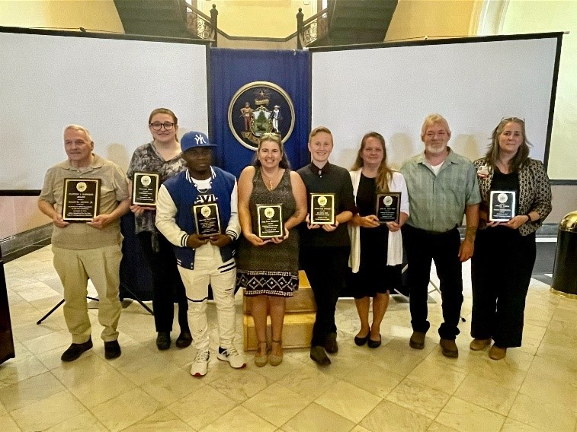
The 32nd Annual Deaf Tea Awards celebration took place on September 21, 2023. Approximately 80 people attended the Annual Tea at the Hall of Flags, State House, in Augusta. Governor Janet Mills addressed the celebration with a pre-recorded video and Commissioner Laura Fortman welcomed everyone at the event.

3

Office of the State Accessibility and Independent Living Coordinator
State ADA Accessibility Highlights
The Accessibility Coordinator leads the State’s compliance under the Americans with Disabilities Act (ADA) and Section 504. The Coordinator works with State agencies to develop and carry out policies and practices regarding services, facilities, web design, and communication. The Coordinator works with customers and departments to resolve any disability-based discrimination complaints.

Several key initiatives continued over the last year, including:

- Information Technology Accessibility Committee (ITAC) of MaineIT – ITAC is a collaboration of many departmental representatives carrying out the Digital Accessibility and Usability Policy. The policy requires access to all State services, programs, and communications using the Internet. Key steps supporting implementation of the policy are:

  - A video giving high-level awareness about functional issues and disability rights for all staff (being developed by the Department of Administrative and Financial Services)
  - A growing cadre of knowledgeable staff throughout departments, providing resources and training; for example, MDOL will be offering ongoing learning opportunities on various platforms in 2023, as well as role-based and in-person training
  - A resource library of digital accessibility training materials in a single place – recorded sessions, self-paced training modules – as well as the MaineIT Accessibility Team page

- With direction from the Department of Administrative and Financial Services, accessibility coordinators are designated in each State agency and listed with a webcast of an introductory overview of ADA responsibilities and accommodations

- State of Maine Policy on Service Animals - Updated policy outlining the State of Maine’s support of employees and the public’s use of service animals. It defines the process of requesting the use of a service animal for State of Maine Employees. It also provides guidance on the use of service animals in state buildings and how to address service animals.

Independent Living Highlights
The State Independent Living (IL) Coordinator oversees contracts with the Independent Living Services Program at Alpha One and the Maine Statewide Independent Living Council (SILC), which support improved community and housing access for people with disabilities. The IL Coordinator works with the Kim Wallace Adaptive Equipment Loan Program, Maine’s flexible loan program for assistive technology, as well as the Travel Helpers Training Program, the Assistive Technology Consortia, and others. The IL Coordinator provides technical assistance and training for Maine businesses and individuals about use of service animals and about disability rights in public accommodations and housing. Public access to outdoor recreation in Maine has garnered widespread recognition and resulted in numerous new State and private trails being built for accessibility, particularly using Recreational Trails Program funding and incorporating user design.

Contact: | Railey Guthrie, ADA Accessibility and IL Coordinator
Tel: | 207-287-5292
TTY: | Call Maine Relay 711
Fax: | (207) 287-5292
E-mail: | railey.b.guthrie@maine.gov

Partners in Advocacy, Advisory Boards and Councils
Client Assistance Program at Disability Rights Maine provides information, advice, advocacy, and (if determined necessary) legal representation to persons who have concerns about the rehabilitation services they receive from DVR and DBVI. Website: https://drme.org/client-assistance-program

Commission for the Deaf, Hard of Hearing and Late Deafened is an advisory council that provides a review of the status of services to Deaf and hard-of-hearing persons, recommends priorities for development, evaluates the progress made as a result of recommendations, and sets goals for activities of DDHHLD to carry out its obligations and responsibilities to the Deaf and hard of hearing communities.
Website: https://www.maine.gov/rehab/advisory_councils/dod

Commission on Disability and Employment (CDE) is a subcommittee of the State Workforce Board. The Commission promotes collaboration with the public and private sectors to increase awareness and influence policy related to employment for people with disabilities. Its members envision a Maine workforce that includes all people with disabilities employed in jobs that meet both their economic and personal needs.
Website: https://www.maine.gov/swb/committees/disability_employment/index.shtml

DBVI State Rehabilitation Council (SRC) is a diverse group of people concerned with the quality of vocational rehabilitation services provided to blind Maine citizens. The SRC’s core functions are to review, analyze, and advise on the policies and practices of DBVI and other related entities involved with the employment of people who are blind or have vision impairments. Website: https://maine-src-dbvi.org

DVR State Rehabilitation Council (SRC) is a statewide citizens group that advises DVR about how well its programs and services match the needs of people with disabilities in Maine. In partnership, the SRC works with DVR to review, analyze, and advise the state agency regarding its performance in providing vocational rehabilitation services. Website: https://mainesrc.org

State Independent Living Council (SILC) promotes a philosophy of independent living, which encompasses consumer control, peer support, self-help, self-determination, and equal access, as well as individual and system advocacy, to maximize the leadership, empowerment, independence and productivity of individuals with significant disabilities. Website: http://mainesilc.org

BRS Office Directory
Central Administrative Office  Bureau of Rehabilitation Services  150 State House Station  Augusta, ME 04333  Tel: 207-623-6799  Fax: 207-287-5292 | From any location:  Tel.: 1-888-457-8883  TTY users call Maine Relay 711
Augusta CareerCenter  45 Commerce Drive  Augusta, ME 04333-0073  Tel: 207-624-5120  Fax: 207-287-6249 | Lewiston CareerCenter  5 Mollison Way  Lewiston, ME 04240-5805  Tel: 207-753-9001  Fax: 207-753-9051
Bangor CareerCenter  45 Oak Street, Suite 1  Bangor, ME 04401-6664  Tel: 207-561-4000  Fax: 207-561-4027 | Machias CareerCenter  53 Prescott Drive  Suite 2,  Machias, ME 04654-9751  Tel: 207-255-1926  Fax: 207-255-3091
Northern Kennebec Valley CareerCenter  23 Stanley Road  Hinckley, ME 04944  Tel: 207-474-4958 or 1-800-760-1572  Fax: 207-474-4914 | Greater Portland CareerCenter  151 Jetport Boulevard  Portland, ME 04102  Tel: 207-822-3300  Fax: 207-775-7870
Houlton DVR Office  11 High Street  Houlton, ME 04730-2421  Tel: 207-532-5019  Fax: 207-532-5309 | Presque Isle CareerCenter  66 Spruce Street  Suite 3,  Presque Isle, ME 04769-3222  Tel: 207-768-6835  Fax: 207-768-6837

https://www.maine.gov/oit/sites/maine.gov.oit/files/inline-files/DigitalAccessibilityPolicy.pdf
https://www.maine.gov/oit/accessibility/resources
https://www.maine.gov/oit/accessibility
https://www.youtube.com/watch?v=X3kJwMjGH10
https://www.maine.gov/bhr/sites/maine.gov.bhr/files/inline-files/SOM%20Service%20Animal%20Policy.pdf
https://www.pbs.org/video/accessible-trails-4ep1zd/

